**Exercise 2: Implementing Dependency Injection**

**Scenario:**

In the library management application, you need to manage the dependencies between the BookService and BookRepository classes using Spring's IoC and DI.

**Steps:**

1. **Modify the XML Configuration:**
   * Update **applicationContext.xml** to wire **BookRepository** into **BookService**.
2. **Update the BookService Class:**
   * Ensure that **BookService** class has a setter method for **BookRepository**.
3. **Test the Configuration:**
   * Run the **LibraryManagementApplication** main class to verify the dependency injection.

**Code:**

*MainApp.java –*

package com.library;

import org.springframework.context.ApplicationContext;

import org.springframework.context.support.ClassPathXmlApplicationContext;

import com.library.service.BookService;

public class MainApp {

public static void main(String[] args) {

// Load Spring context

ApplicationContext context = new ClassPathXmlApplicationContext("applicationContext.xml");

// Get BookService bean

BookService bookService = context.getBean("bookService", BookService.class);

// Test

bookService.addBook("One Piece");

}

}

*BookService.java –*

package com.library.service;

import com.library.repository.BookRepository;

public class BookService {

private BookRepository bookRepository;

// Setter for dependency injection

public void setBookRepository(BookRepository bookRepository) {

this.bookRepository = bookRepository;

}

public void addBook(String bookName) {

System.***out***.println("Adding book: " + bookName);

bookRepository.saveBook(bookName);

}

}

*BookRepository.java –*

package com.library.repository;

public class BookRepository {

public void saveBook(String bookName) {

System.***out***.println("Book saved: " + bookName);

}

}

*applicationContext.xml –*

<?**xml** version=*"1.0"* encoding=*"UTF-8"*?>

<**beans** xmlns=*"http://www.springframework.org/schema/beans"*

xmlns:xsi=*"http://www.w3.org/2001/XMLSchema-instance"*

xsi:schemaLocation=*"*

*http://www.springframework.org/schema/beans*

*http://www.springframework.org/schema/beans/spring-beans.xsd"*>

<!-- Define Repository Bean -->

<**bean** id=*"bookRepository"* class=*"com.library.repository.BookRepository"*/>

<!-- Define Service Bean with Dependency Injection -->

<**bean** id=*"bookService"* class=*"com.library.service.BookService"*>

<**property** name=*"bookRepository"* ref=*"bookRepository"*/>

</**bean**>

</**beans**>

*Pom.xml –*

<project xmlns="http://maven.apache.org/POM/4.0.0" xmlns:xsi="http://www.w3.org/2001/XMLSchema-instance" xsi:schemaLocation="http://maven.apache.org/POM/4.0.0 https://maven.apache.org/xsd/maven-4.0.0.xsd">

<modelVersion>4.0.0</modelVersion>

<groupId>com.library</groupId>

<artifactId>LibraryManagement</artifactId>

<version>0.0.1-SNAPSHOT</version>

<dependencies>

<!-- Spring Core -->

<dependency>

<groupId>org.springframework</groupId>

<artifactId>spring-context</artifactId>

<version>5.3.33</version>

</dependency>

</dependencies>

</project>

**Output: (Screenshots)**

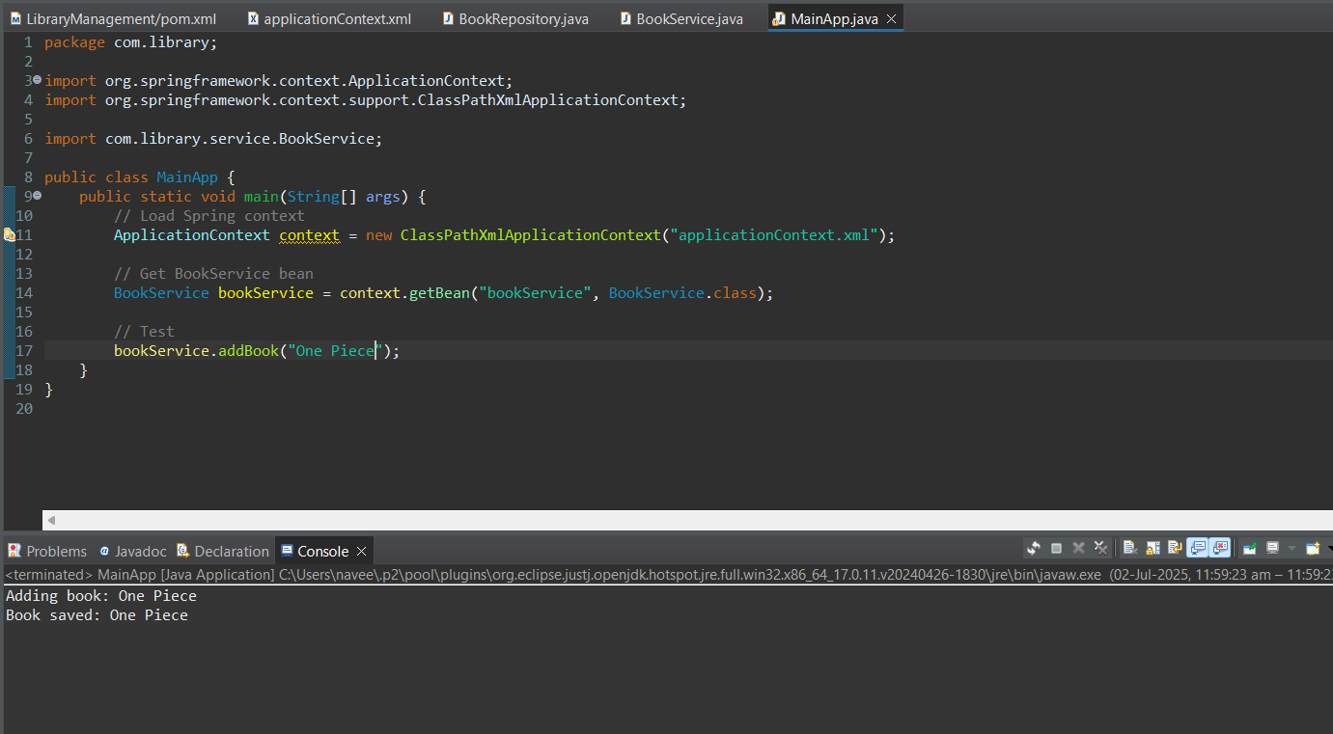

**Project Structure –**

